es
Sr. No. | Product Name | PHOTOGRAPHS | DESCRIPTIONS
01 | NAPKIN INCINERATOR | 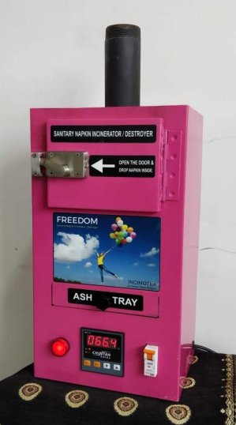 | ‘FREEDOM’ NAPKIN INCINERATOR  FULLY AUTOMATIC  COMPACT DESIGN  PREMIUM QUALITY  LAVISH LOOK  USER FRIENDLY  PLUG & PLAY TYPE  MICRO PROCESSOR BASED  POWER SAVING  RIGID CONSTRUCTIONS  HIGH INSULATION  LOW SURFACE TEMPERATURE  TABLE TOP AS WELL WALL MOUNTABLE

02 | DOCUMENT DESTROYER | 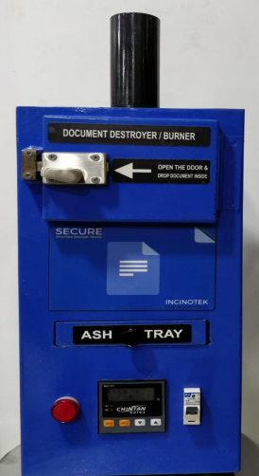 | `SECURE’ DOCUMENT DESTROYER  FULLY AUTOMATIC  COMPACT DESIGN  PREMIUM QUALITY  LAVISH LOOK  USER FRIENDLY  PLUG & PLAY TYPE  MICRO PROCESSOR BASED  POWER SAVING  RIGID CONSTRUCTIONS  HIGH INSULATION  LOW SURFACE TEMPERATURE  TABLE TOP AS WELL WALL MOUNTABLE

